Student Activity
25 Connecting circuits

TASK
To interpret and construct basic electrical circuits from a circuit diagram.

THEORY
An electrical circuit must have several key components in order to work:
• a power supply
• a load that adds some resistance to the circuit
• an unbroken current path around the circuit from one terminal of the power supply to the other.

EQUIPMENT
• variable power supply
• connecting wires
• two 6 V globes in holders
• rheostat or variable resistor
• switch

NOTES ON METHOD

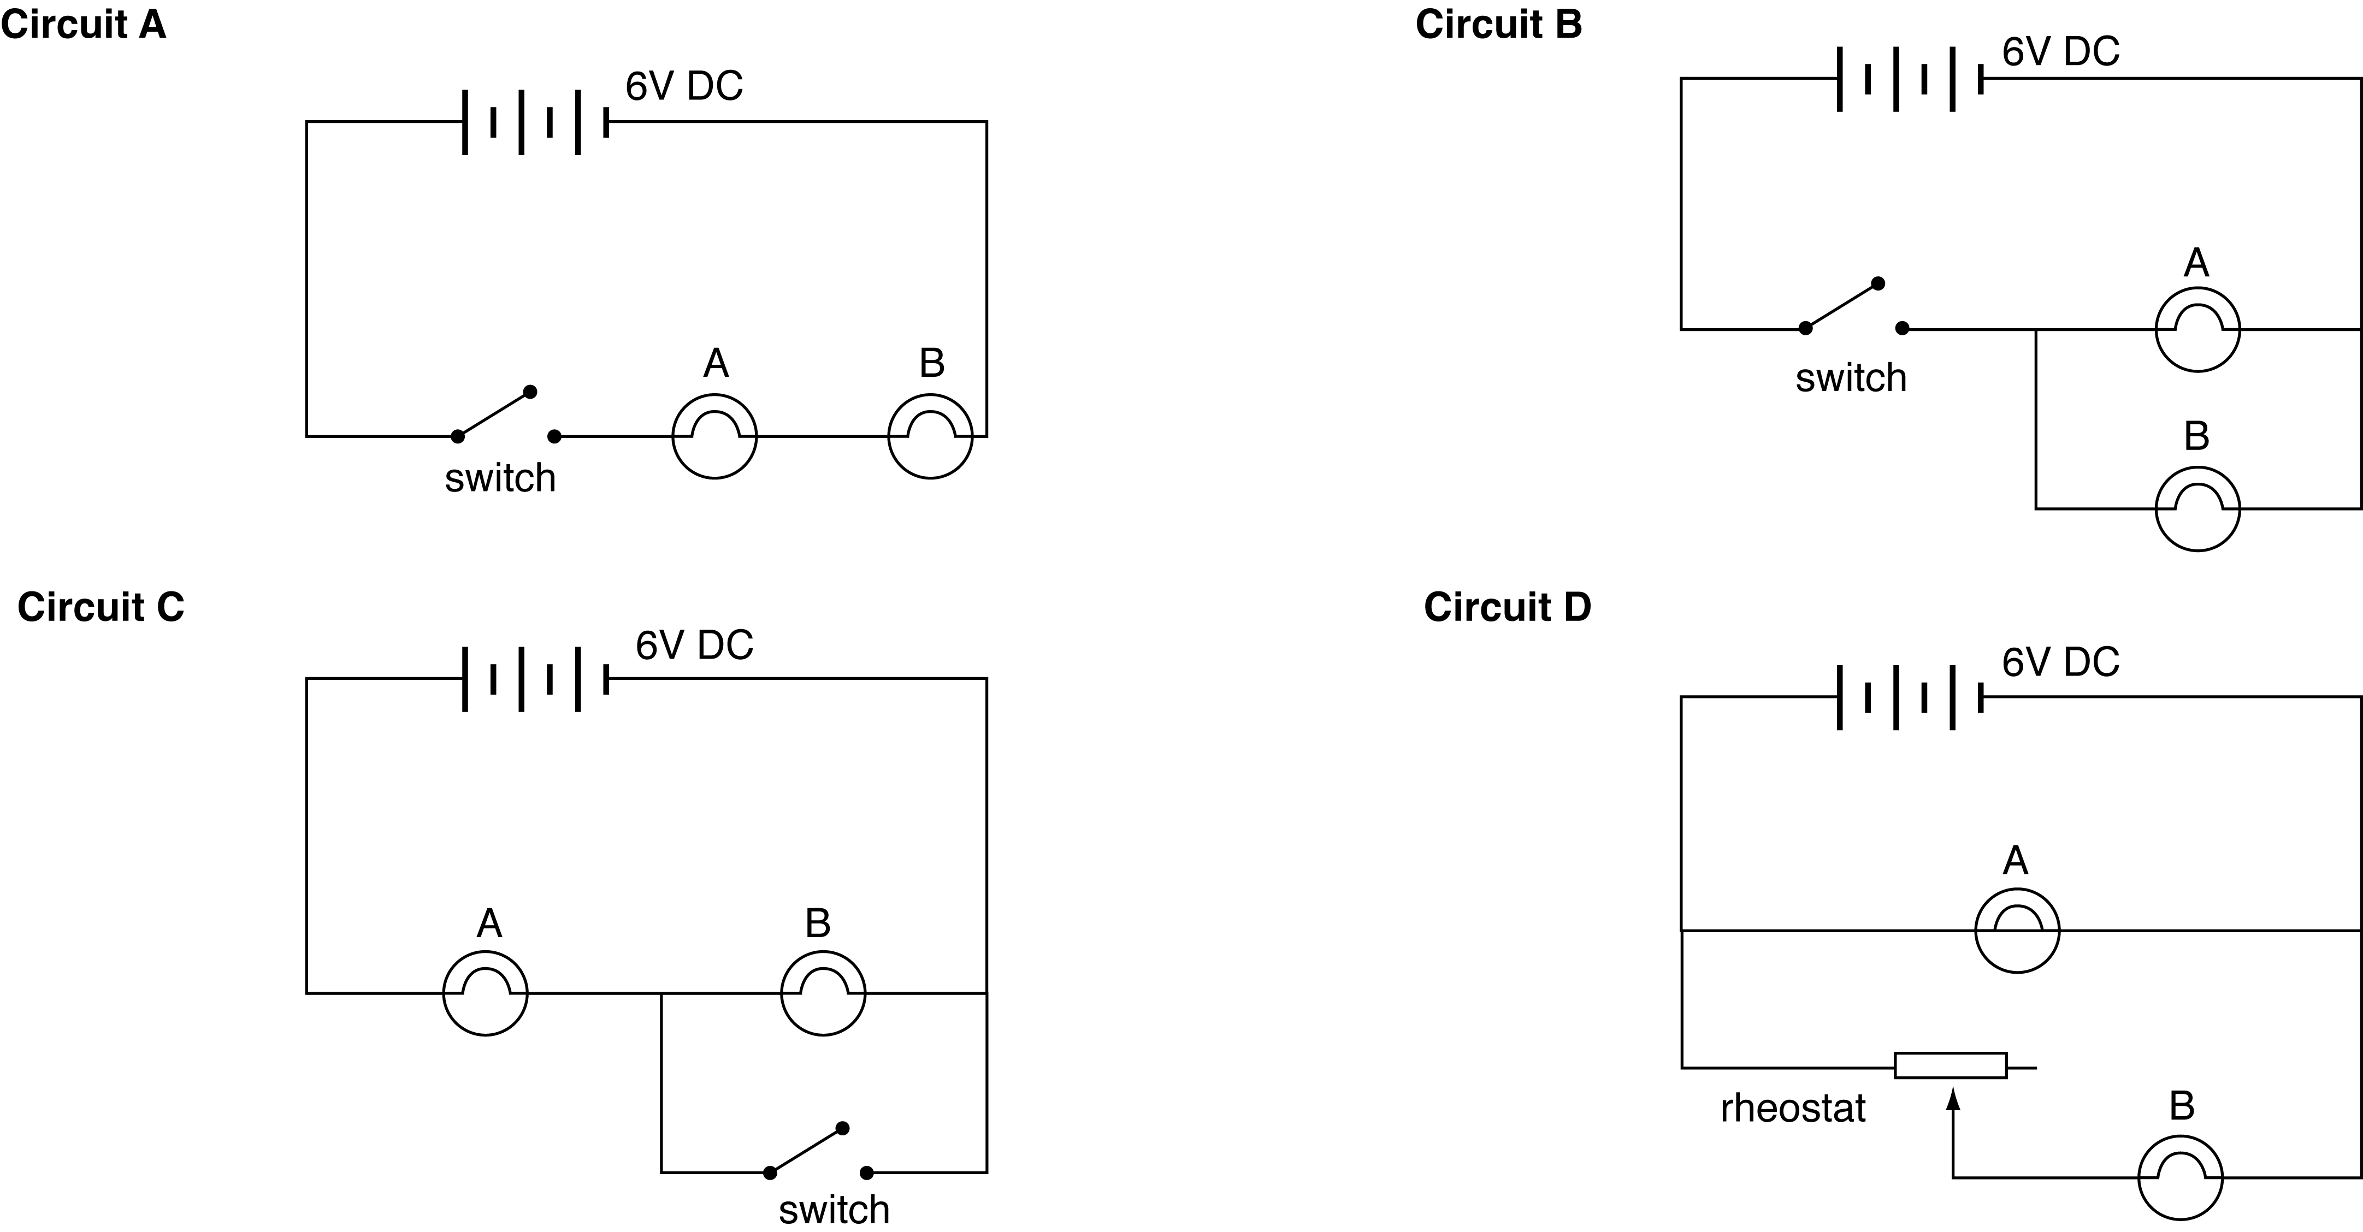
Circuit A
1. Connect circuit A by starting at the positive terminal of the power supply and working around to the negative terminal. This is referred to as a series circuit.
2. Set the voltage on the power supply to 6 V and turn the power supply on.
Close the switch when you are ready.
Note the relative brightness of the globes.
3. Now take globe A out of its holder. Record your observations.

Circuit B
1. Connect circuit B by starting at the positive terminal of the power supply and working around to the negative terminal including just globe A.
Finally, connect globe B in parallel to globe A as shown in the circuit diagram.
2. Set the voltage on the power supply to 6 V and turn the power supply on.
Close the switch when you are ready. Note the relative brightness of the globes.
3. Now take globe A out of its holder. Record your observations.

Circuit C
1. Connect circuit C by starting at the positive terminal of the power supply and working around to the negative terminal, inserting globe A and globe B.
Finally, connect the switch in parallel to globe B, as shown in the circuit diagram.
2. Set the voltage on the power supply to 6 V and turn the power supply on.
Close the switch when you are ready. Record your observations.
continued
25 Connecting circuits
Circuit D
1. Connect circuit D by starting at the positive terminal of the power supply and working around to the negative terminal including just globe A.
Connect the rheostat (or variable resistor) and globe B in parallel, as shown in the circuit diagram.
2. Set the voltage on the power supply to 6 V and turn the power supply on.
3. Adjust the rheostat through its full range. Record your observations.

CONCLUSION
Summarise your findings for each circuit.

QUESTIONS
1. Circuit A: When globe A was taken out of its holder, what happened to globe B?
Explain your observations. What problems do you foresee with this arrangement?
2. Circuit B: When globe A was taken out of its holder, what happened to globe B?
Explain your observations.
3. Circuit C: What happened to globe B when the switch was closed?
Explain your observations.
4. Circuit D: What happened to the globes when the rheostat was altered?
Explain your observations.
5. What practical application can you think of for each circuit around the home?
Explain why each circuit would be suitable for the use you suggest.

EXTENSION ACTIVITY
In many households a two-way switch at either end of a hallway allows a light to be turned on or off at either end.
Draw a circuit, including one other globe in parallel and two switches, that would allow this result to occur.

